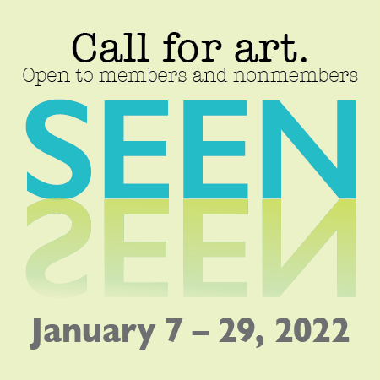

Official Entry Form

January Juried Exhibit 2022

Carlisle Arts Learning Center, 38 W. Pomfret St. Carlisle, PA 17013

717-249-6973 www.carlislearts.org

Artist Name:___________________________________________ Address:______________________________________________ City:_______________ State: ____________ Zip: _____________

Daytime phone:____________ Evening/Cell Phone:____________

E-Mail address:_________________________________________

**Entry #1**

Title:_______________________________

Medium: ________________________

Year:___________________________

Dimensions:

H______ W______ D______ inches

Price or value for insurance:$________

**Entry #2**

Title:_______________________________

Medium: ________________________

Year:___________________________

Dimensions:

H______ W______ D______ inches

Price or value for insurance:$________

Please provide an artist resume/bio and a statement about the works submitted.

Visit [www.carlislearts.org/exhibits](http://www.carlislearts.org/exhibits) for online submission information.

We wish this to be an open opportunity for all. If payment of the Jury Fee would prevent an artist from entering due to current circumstances, please contact CALC for a waiver at info@carlislearts.org

Deadline for Submission:

**November 22, 2021**

**Members: $20/ Non-Members $35**

**Notifications by Dec.3, 2021**

*Accepted Works must be delivered to CALC between:*

*Mon., Dec. 13 – Sat., Dec. 20, 2021*

Shipped work must include

pre-paid return shipping label.

*Exhibit Dates:*

**Friday January 7 - Saturday, January 29, 2022**

Agreement:

All entries are my original work from original sources and the information I have provided is true and correct. I give my permission for CALC to document my work and reproduce my images solely for educational and promotional purposes.

Artists agree to hold CALC and their employees harmless in any claim from damage or theft of any kind during the receipt, hanging and run of the exhibit, as well as the packaging and return shipment of work. Artists should arrange for proper insurance coverage. Entry to the show constitutes acceptance of conditions.

*Artist’s Signature*

X__________________________________________